A000-ME-Mesopotamia-Sumeria-Lagash-Gudea Statue-Diorite-2144-2124 BCE

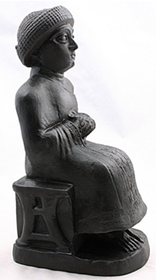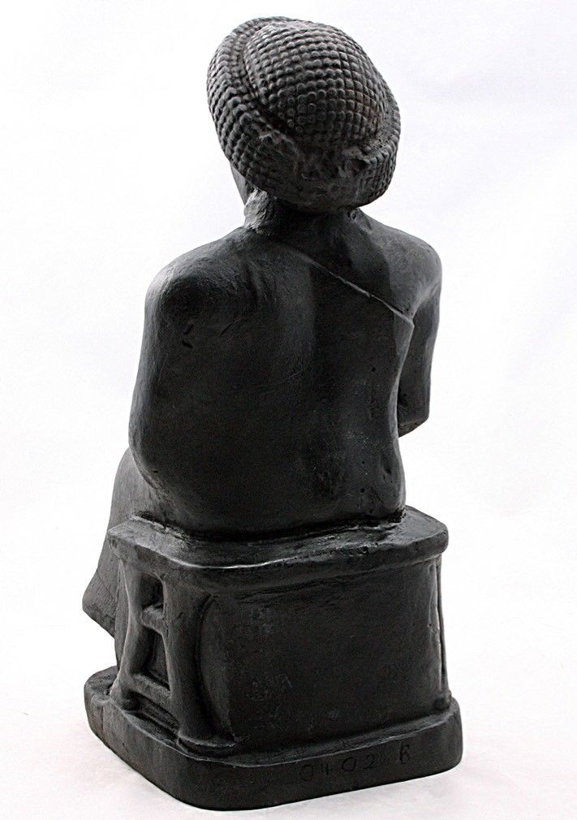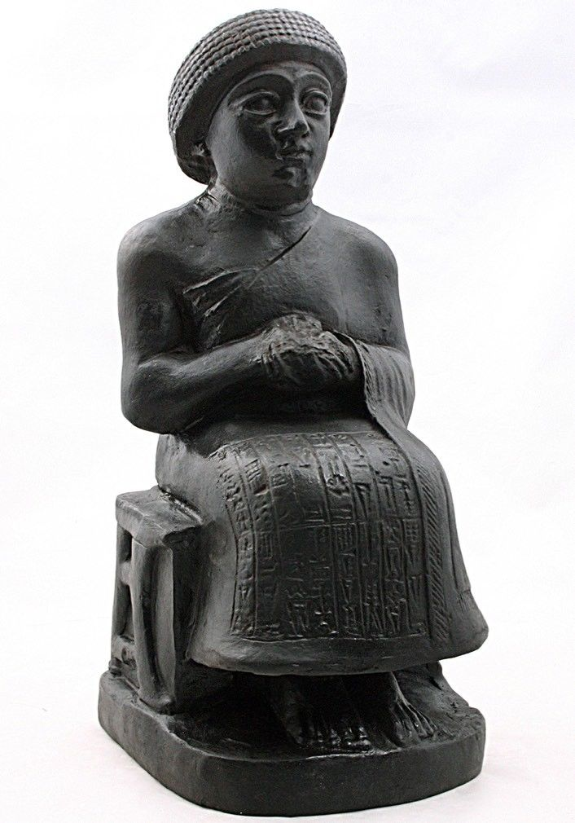

Fig. 1, a-c. Mesopotamia-Sumeria-Lagash-Gudea Statue-Diorite-2144-2124 BCE

Formal Label: Mesopotamia-Sumeria-Lagash-Gudea Statue-Diorite-2144-2124 BCE

Accession Number: PJ4070.A1

**Display description:** Gudea was a ruler or *ensi* of the Sumerian city of Lagash in Southern Mesopotamia who ruled ca. 2144 - 2124 BCE. He probably did not come from the city, but had married Ninalla, daughter of the ruler Urbaba (2164 - 2144 BCE) of Lagash, thereby gaining entrance to the royal house of Lagash. He was succeeded by his son Ur-Ningirsu (ca. 2125–2100 BCE). This reproduction is an excellent example of the sculpture of the Sumerian Renaissance in Southern Mesopotamia during the Third Dynasty of Ur.

Date or Time Horizon: ca. 2144 - 2124 BCE

Geographical Area: Mesopotamia-Sumeria-Lagash

Map:

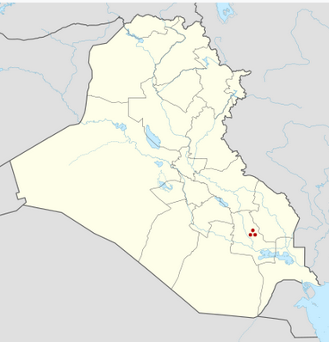

Mesopotamia-Sumeria-Lagash-within Iraq after https://upload.wikimedia.org/wikipedia/commons/thumb/8/80/Iraq_adm_location_map.svg/428px-Iraq_adm_location_map.svg.png

GPS: [31°24′41″N 46°24′26″E](https://tools.wmflabs.org/geohack/geohack.php?pagename=Lagash&params=31_24_41_N_46_24_26_E_type:landmark)

Cultural Affiliation: Sumerian

Medium: original, diorite.

Dimensions: 14 in H x 6 in W x 6 3/4 in D.

Weight: 4.9 lbs

Provenance: original, Metropolitan Museum of Art. Replica, Atlantika.

**Discussion:**

The city-state of Lagash produced many statues of its kings under Gudea and his son Ur-Ningirsu Sumerian literary hymns and prayers flourished, but these were pious undertakings and reflected a sense of reserve and serenity which is attained also in this sculpture. This serene and aloof social atmosphere differs from the art of the preceding Akkadian period, which was characterized by a dynamic naturalism.

Diorite statues commissioned by Gudea memorialize his rebuilding the great temples of Lagash where statues of himself were ensconced. Inscriptions on them include his name and pious, divine dedications. In this sculpture Gudea is the ruler addressing his subjects, with his hands clasped in a Sumerian gesture of supplication to the gods. On his robe the temples he built or renovated in Lagash are listed ending with the formulaic statement “Gudea, the man who built the temple; may his life be long.”

**References:**

Hibbard, Howard. 1980. *The Metropolitan Museum of Art*. New York: Harper and Row, fig. 112, p. 53.

Johansen, Flemming. 1978. *Statues of Gudea: Ancient and Modern*. Mesopotamia 6. Copenhagen: Akademisk Forlag

Metropolitan Museum of Art. 1970. *Masterpieces of Fifty Centuries*. New York: Dutton, no. 5, p. 78.

Mornand, Pierre. 1931. "Une Nouvelle Statue de Gudea." *Beaux-Arts*, March 1931, p. 26.

Redmond, Roland L., and James J. Rorimer. 1959. "Review of the Year 1958-1959: Report of the President and of the Director." *The Metropolitan Museum of Art Bulletin* 18 (2), Eighty-Ninth Annual Report of the Trustees for the Fiscal Year 1958-1959 (Oct.), p. 34.

Scheil, Vincent. 1930. "Nouvelles statues de Gudea." *Revue d'Assyriologie* 27 (4), pp. 163-164, pls. III, IV.  
Woolley, C. Leonard. 1935. *The Development of Sumerian Art*. London: Faber and Faber Ltd., pl. 61a,b.